ELA Year at a Glance

Module One: Greek Mythology and Myths
- Percy Jackson as a hero
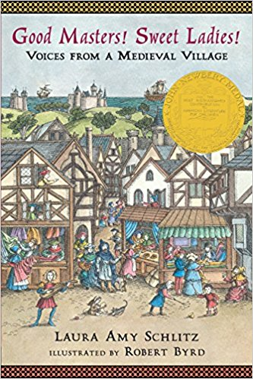
- Elements and Themes of Greek Mythology
- Creating your own hero

Module Two: Voices of Adversity
- Adversities in Medieval Times
- Different literary styles
- Adversities in the modern world

Module Three: To be Determined

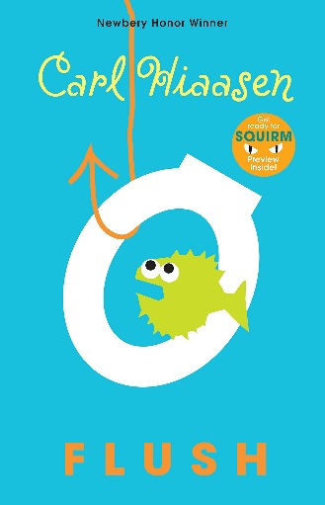

Grades this Year:
- Major= 60% (Mid Unit Assessments, Final Unit Assessment, Essays
& Projects)
- Minor= 40% (Classwork & Homework)

Grading Scale:
90-100% A
80-89% B
70-79% C
60-69% D
59- 0% F
I do not round grades on tests, quizzes, assignments or projects!!

